## Acceleration Bands (ABANDS)

## The Acceleration Bands (ABANDS) created by Price Headley plots upper and lower envelope bands around a simple moving average. The width of the bands is based on the formula below.

*Acceleration bands are set as an envelope around a 20 period simple moving average on equal distance from it.*

We want to achieve maximum movement in the stock over the least amount of time possible.

Headley, the inventor of the Acceleration Bands indicator suggests using them on weekly and monthly timeframes to determine price acceleration breakouts (breakouts outside the bands).

**Idea Behind Acceleration Bands Indicator : highly useful to check when the market is Aggressive (we can check the acceleration on minutes)**

Acceleration Bands principal use is in finding the acceleration in currency pair price and benefit as long as this acceleration preserves.

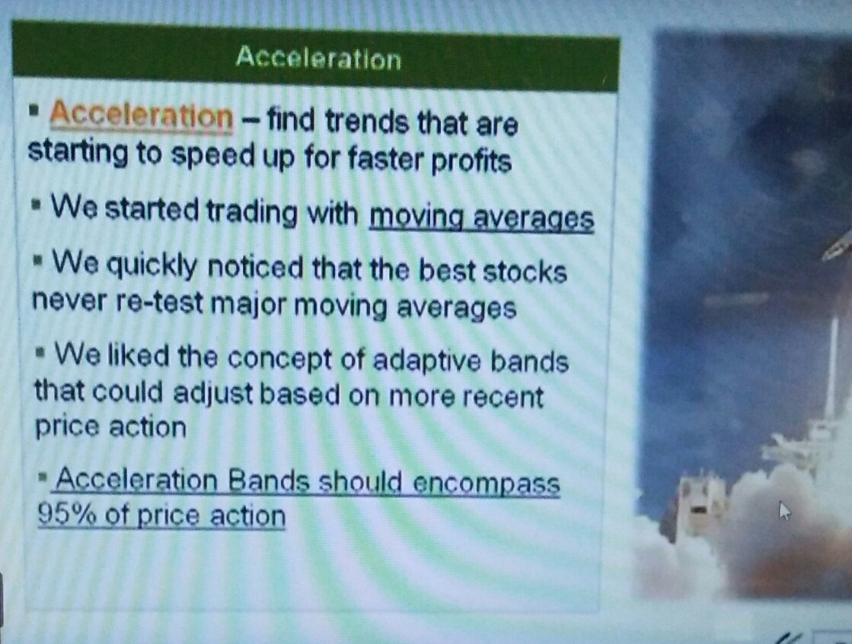

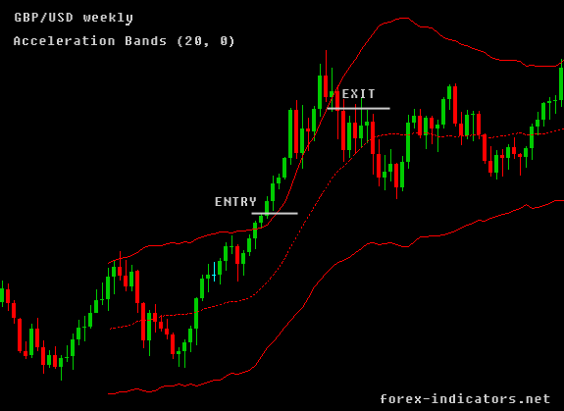

1. Usually I am **looking at the last 20 bars** on the Acceleration Bands. On a daily chart, this incorporates roughly the last month’s trading activity, while on a weekly chart, this covers four-and-a-half months, and a monthly chart covers just over one-and-a-half years of price action.
2. The **upper and lower Acceleration Bands are plotted equidistant from the simple 20-period simple moving average** (the middle blue line in the charts below). A daily chart shows a 20-day moving average, and a weekly chart plots a 20-week moving average.
3. **Acceleration Bands adjust for a stock’s volatility**: the more volatile the stock’s price action over the last 20 periods, the wider the Bands will be around the moving average

**Volatality** - liability to change rapidly and unpredictably, especially for the worse.

* If the price of a stock moves up and down rapidly over short time periods, it has high volatility. If the price almost never changes, it has low volatility.

1. **Once I see two consecutive closes above the upper Acceleration Band, I get a buy signal** – on trending stocks, this will often lead to a major upside acceleration move. On choppy trading range stocks, this will often be a “head fake.” I use historical data, other indicators, and several entry and exit rules to further narrow down the signals.

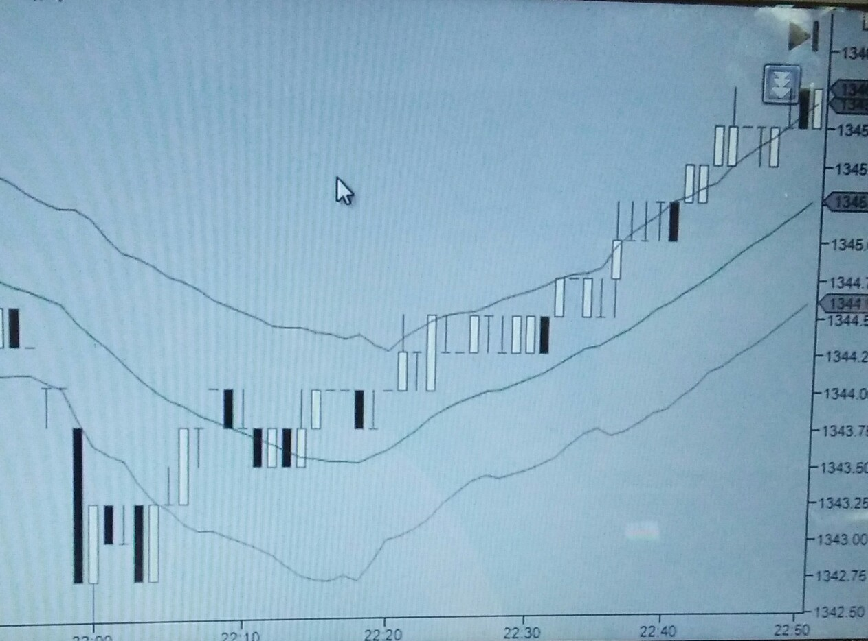

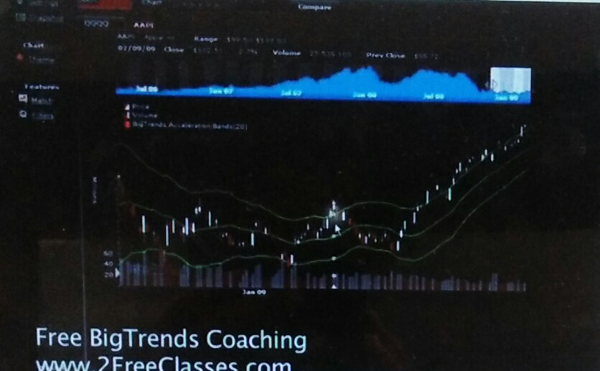

1. One close back into the Acceleration Band signals a traditional exit of the trade, as the Acceleration period is now likely to end.

**Bearish Example** : The first break below the lower band led to a brief but sharp decline at the start of 2008, with the 2nd Acceleration break down signal coming within 7 days of the company’s massive plunge that took the stock down from the 60’s down to less than $4 per share.

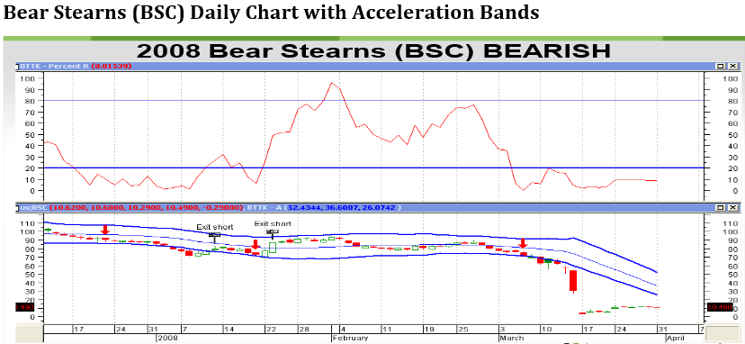

**Example:**

## When Acceleration Bands are used for smaller time frames , upper and lower bands are treated as levels of possible support and resistance.

|  |
| --- |
| * Upper Band = Simple Moving Average (High * ( 1 + 4 * (High - Low) / (High + Low))) |
| * Middle Band = Simple Moving Average |
| * Lower Band = Simple Moving Average (Low * (1 - 4 * (High - Low)/ (High + Low)) |

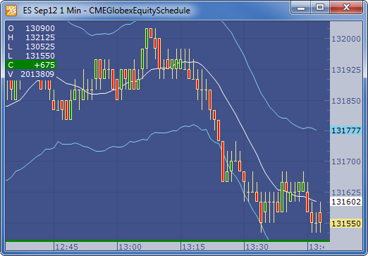

Most investors like to buy stocks near their 52-week low and hope it returns to the 52-week high.

|  |  |  |  |  |
| --- | --- | --- | --- | --- |
| **Date** | **Open** | **High** | **Low** | **Close** |
| 1/3/2012 | 325.25 | 332.83 | 324.97 | 663.59 |
| 1/4/2012 | 331.27 | 333.87 | 329.08 | 666.45 |
| 1/5/2012 | 329.83 | 330.75 | 326.89 | 657.21 |
| 1/6/2012 | 328.34 | 328.77 | 323.68 | 648.24 |
| 1/9/2012 | 322.04 | 322.29 | 309.46 | 620.76 |
| 1/10/2012 | 313.7 | 315.72 | 307.3 | 621.43 |
| 1/11/2012 | 310.59 | 313.52 | 309.4 | 624.25 |
| 1/12/2012 | 314.43 | 315.26 | 312.08 | 627.92 |
| 1/13/2012 | 311.96 | 312.3 | 309.37 | 623.28 |
| 1/17/2012 | 314.81 | 314.81 | 311.67 | 626.86 |
| 1/18/2012 | 312.14 | 315.82 | 309.9 | 631.18 |
| 1/19/2012 | 319.3 | 319.3 | 314.55 | 637.82 |
| 1/20/2012 | 294.16 | 294.4 | 289.76 | 584.39 |
| 1/23/2012 | 291.91 | 293.23 | 290.49 | 583.92 |
| 1/24/2012 | 292.07 | 292.74 | 287.92 | 579.34 |
| 1/25/2012 | 287.68 | 288.27 | 282.13 | 567.93 |
| 1/26/2012 | 284.92 | 286.17 | 281.22 | 566.54 |
| 1/27/2012 | 284.32 | 289.08 | 283.6 | 578.39 |
| 1/30/2012 | 287.95 | 288.92 | 285.63 | 576.11 |
| 1/31/2012 | 290.41 | 290.91 | 286.5 | 578.52 |

|  |  |  |  |  |  |  |
| --- | --- | --- | --- | --- | --- | --- |
| **High - Low** | **(High + Low)** | **((High - Low)/(High+Low))** | **4*((High - Low)/(High+Low))** | **1+4*((High - Low)/(High+Low))** | **High *(1+4*((High - Low)/(High+Low)))** | **Upper band** |
| 7.86 | 657.8 | 0.011948921 | 0.0477957 | 1.04779568 | 348.737837 |  |
| 4.79 | 662.95 | 0.007225281 | 0.0289011 | 1.02890112 | 343.5192182 |  |
| 3.86 | 657.64 | 0.005869473 | 0.0234779 | 1.02347789 | 338.5153123 |  |
| 5.09 | 652.45 | 0.007801364 | 0.0312055 | 1.03120546 | 339.0294179 | 343.590789 |
| 12.83 | 631.75 | 0.020308666 | 0.0812347 | 1.08123467 | 348.4711204 | 340.354649 |
| 8.42 | 623.02 | 0.013514815 | 0.0540593 | 1.05405926 | 332.7875895 | 342.005284 |
| 4.12 | 622.92 | 0.006614011 | 0.026456 | 1.02645605 | 321.8144995 | 340.096043 |
| 3.18 | 627.34 | 0.005069022 | 0.0202761 | 1.02027609 | 321.652239 | 334.357736 |
| 2.93 | 621.67 | 0.004713111 | 0.0188524 | 1.01885245 | 318.1876188 | 325.418109 |
| 3.14 | 626.48 | 0.005012131 | 0.0200485 | 1.02004853 | 321.1214762 | 320.551452 |
| 5.92 | 625.72 | 0.009461101 | 0.0378444 | 1.0378444 | 327.7720194 | 320.320445 |
| 4.75 | 633.85 | 0.007493887 | 0.0299755 | 1.02997555 | 328.8711919 | 322.360371 |
| 4.64 | 584.16 | 0.007943029 | 0.0317721 | 1.03177212 | 303.7537113 | 325.921563 |
| 2.74 | 583.72 | 0.004694031 | 0.0187761 | 1.01877613 | 298.7357233 | 320.132308 |
| 4.82 | 580.66 | 0.008300899 | 0.0332036 | 1.0332036 | 302.4600207 | 310.453542 |
| 6.14 | 570.4 | 0.010764376 | 0.0430575 | 1.0430575 | 300.6821865 | 301.649818 |
| 4.95 | 567.39 | 0.008724158 | 0.0348966 | 1.03489663 | 296.1563692 | 300.625977 |
| 5.48 | 572.68 | 0.009569044 | 0.0382762 | 1.03827618 | 300.1448767 | 299.766192 |
| 3.29 | 574.55 | 0.005726221 | 0.0229049 | 1.02290488 | 295.5376785 | 298.994477 |
| 4.41 | 577.41 | 0.007637554 | 0.0305502 | 1.03055022 | 299.7973632 | 297.279641 |

|  |  |  |  |
| --- | --- | --- | --- |
| **1-4*((High - Low)/(High+Low))** | **Low(1-4*((High - Low)/(High+Low)))** | **Lower Band** | **Middle band** |
| 0.952204317 | 309.437837 |  |  |
| 0.971098876 | 319.569218 |  |  |
| 0.976522109 | 319.215312 |  |  |
| 0.968794544 | 313.579418 | 316.074123 | 27.51666667 |
| 0.918765334 | 284.32112 | 317.454649 | 22.9 |
| 0.94594074 | 290.687589 | 305.705284 | 36.3 |
| 0.973543954 | 301.214499 | 296.196043 | 43.9 |
| 0.979723914 | 305.752239 | 292.074403 | 42.28333333 |
| 0.981147554 | 303.537619 | 299.218109 | 26.2 |
| 0.979951475 | 305.421476 | 303.501452 | 17.05 |
| 0.962155597 | 298.172019 | 304.903778 | 15.41666667 |
| 0.970024454 | 305.121192 | 302.377038 | 19.98333333 |
| 0.968227883 | 280.553711 | 302.904896 | 23.01666667 |
| 0.981223874 | 285.035723 | 294.615641 | 25.51666667 |
| 0.966796404 | 278.360021 | 290.236876 | 20.21666667 |
| 0.956942496 | 269.982187 | 281.316485 | 20.33333333 |
| 0.965103368 | 271.406369 | 277.792643 | 22.83333333 |
| 0.961723825 | 272.744877 | 273.249525 | 26.51666667 |
| 0.977095118 | 279.087679 | 271.377811 | 27.61666667 |
| 0.969449784 | 277.747363 | 274.412975 | 22.86666667 |

**Use Cases**

**Used in stockmarket to find the fluctuations.**

**Acceleration moving averges is used Fetcher[Show stocks where high crossed below the lower *acceleration band*(20)] .**

**Used in Bussiness ,Health care Sectors etc.**

**Python**

from datetime import datetime

import backtrader as bt

import numpy as np

import pandas as pd

from math import sqrt

import matplotlib.pyplot as plt

data = pd.read_csv('C:\\Users\\Rama\\Desktop\\INR.csv')

#x

High = data.iloc[:,3]

Low = data.iloc[:,4]

Close = data.iloc[:,5]

upper = (High * ( 1 + 4 * (High - Low) / (High + Low)))

lower = (Low * (1 - 4 * (High - Low)/ (High + Low)))

def movingaverage(values,window) :

weights=np.repeat(1.0,window)/window

smas=np.convolve(values,weights,'valid')

return smas

BUP= movingaverage(upper,20)

BDOWN=movingaverage(lower,20)

BMIDDLE=movingaverage(Close,20)

plt.figure(figsize=(10,5))

plt.plot(data['Close'],lw=1, label='NSE Prices')

plt.plot(BUP,'g',lw=1, label='20-day BUP(green)')

plt.plot(BDOWN,'r', lw=1, label='20-day BDOWN(red)')

plt.plot(BMIDDLE,'y', lw=1, label='20-day BMIDDLE(yellow)')

plt.legend(loc=2,prop={'size':11})

plt.grid(True)

plt.setp(plt.gca().get_xticklabels(), rotation=30)